* **HTML**
* HTML – Hyper Text Markup Language
* Important tags in html

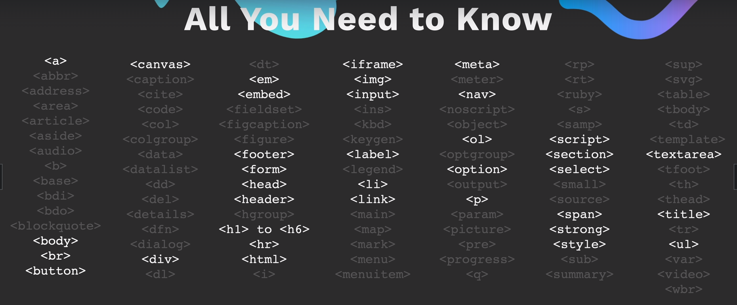

* It is good to use single h1 in any context
* <hr> tag is used to separate the two paragraphs.
* <br> tag is used to break the line at some point.
* **List Element**
* syntax for <ul> tag

<ul>

<li></li>

</ul>

* syntax for <ol> tag

<ol>

<li></li>

</ol>

* **Anchor tag**
* <a> is anchor tag to represent a hyper link
* Syntax for <a> is

<a href=<https://www.google.com>>Google</a>

* Draggable attribute used to allow to drag the element
* Syntax for that

<a draggable=true>google</a>

* **Image Tag**
* Image tag syntax

<img src=”url”>

* Alternate text provide for the image as follows

<img src=”url” alt=”beautiful”>

* HTML paragraphs
* Tags

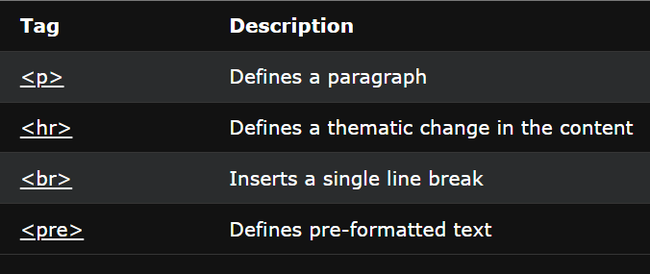

* HTML Styles

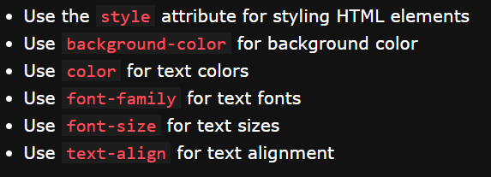

* HTML Formatting

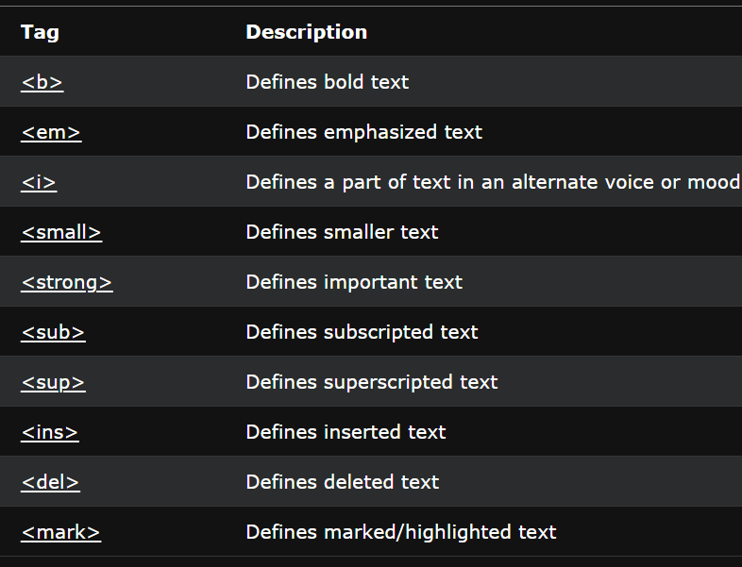

* HTML Quotations

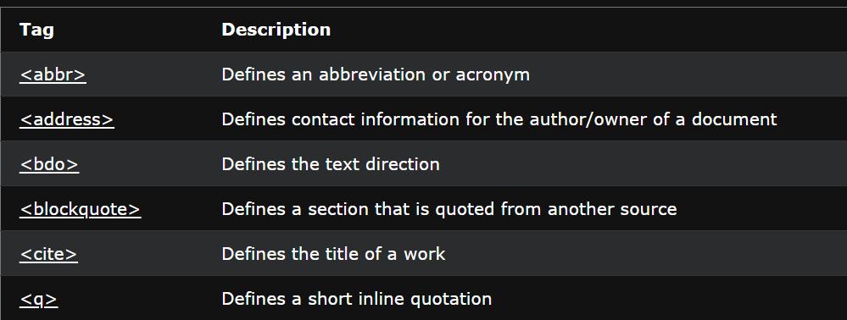

* HTML Links
* Target attribute

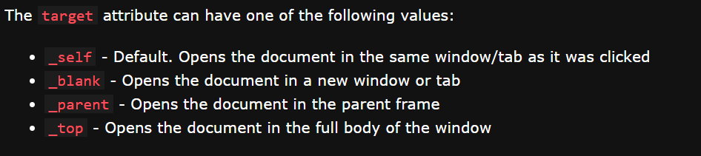

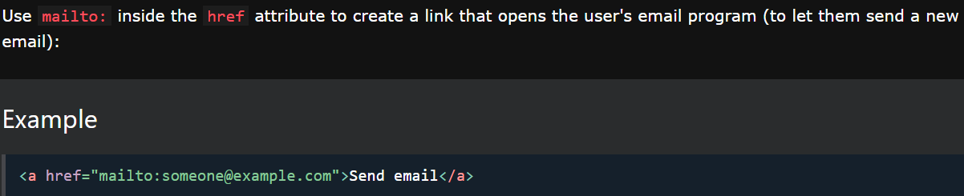

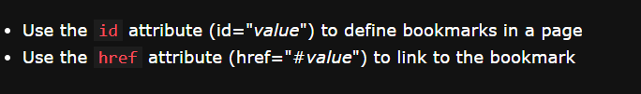

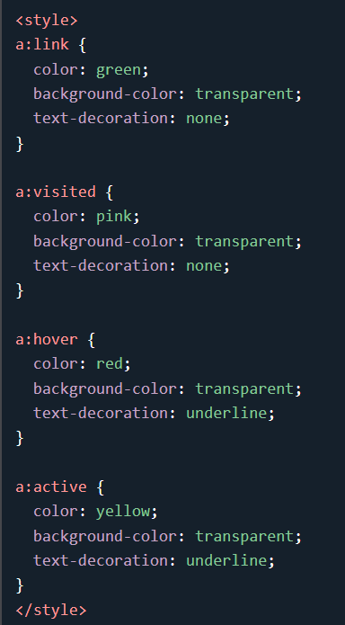

* HTML Images

